**TFL Operations Colleague Observation Process**

* After the Observations Canvas App is shared for the Operations Colleague, the user will install PowerApps mobile app from Play Store/Ios Store and login with their credentials.
* 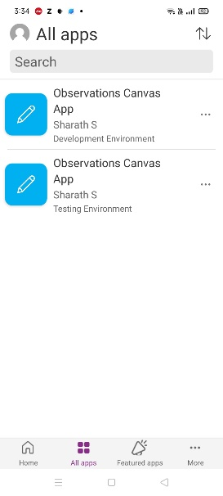Upon logging in the user will be seeing below apps
* Open the canvas app based on environment, here we are testing for Test environment.
* After clicking on Login button of the above screen will land you to Home Page of the app, which will have below
  + Search box for searching observations based on subject in the gallery.
  + Vertical Gallery showing list of active observations and navigation icon for navigating to the observations selected.
  + Create + button for creating new observations.
  + Logout button(next to operations colleague welcome message) to navigate to Login page.
  + Welcome text for the Operations Colleague logged into the app.

* 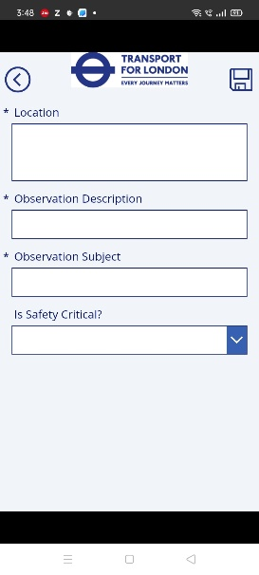For Creating new observations click on “+” button and will navigate to below screen where you can enter the details for Location, Subject, Description and Flag Is Safety Critical to High or Normal.  
    
    
    
    
    
  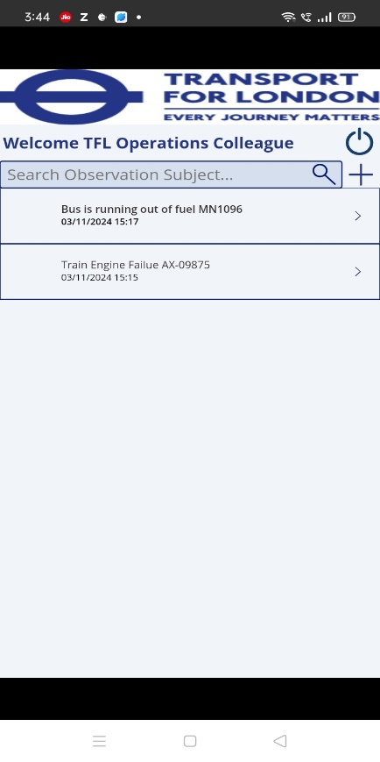
* 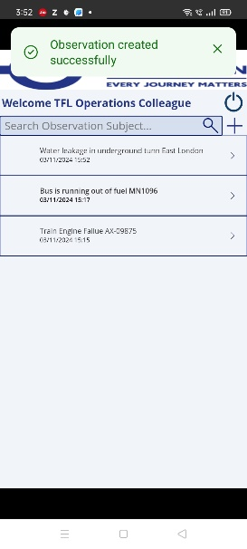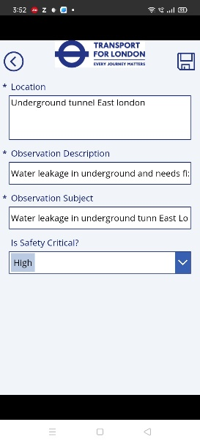Enter the details in the above and click on save icon to save the details and below message will appear.
* Open the saved observation in the gallery and below screen would appear like Create screen along with few additional options to capture image and upload. Operations colleague can capture multiple images and upload them to CE.
  + Camera icon for capturing images.
    - Upon clicking this icon will open the camera page, where you have option to swap the camera (front to back and vice versa) and click on screen to capture the image.
  + Reset icon to reset the captured image.
  + Preview Image section to preview the image.
  + 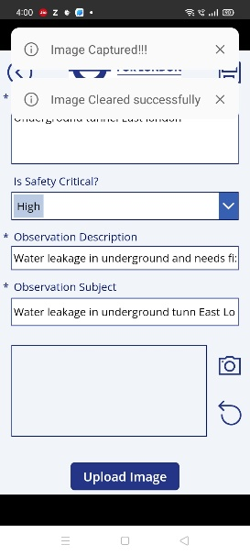Upload Image to create the notes along with images captured.

